Sprint 3

Group 29

Professional Computing [3200]

Members: Finn, Charles, Sultan, Geraldine, Ann, Tyson

**User Manual**

CITS3200 Group 29 Sprint 2

Ann Roy (23132836), Charles So (23199336), Finn O'Callaghan (22975893), Geraldine Chin (22972043), Sultan Alqemzi (22880665), Tyson Tran (22834433)

Table of Contents

Introduction 2

Quick Start Guide 3

Features 4

1.Attendees Manager 4

2.Event Manager 5

3.Email manager 6

Overview of the CRM application 7

Power Apps 7

Reasons for App Design Choice 7

Set Up Instructions 8

Starting Power Apps for the first time 8

Downloading the Power App into your environment 9

Downloading Data into the App 10

Integration with Sharepoint 11

# Introduction

This app was made using Microsoft 365 apps (Dataverse, Powerapp).

As a WAMSI employee you will be using this App through the organization's Sharepoint page to be able to do the following: -

* As a WAMSI employee, manage contacts in PowerApp.
* As a WAMSI employee, handle events in PowerApp.
* As a WAMSI employee, book client meetings in PowerApp.
* As a WAMSI employee, analyze event data in PowerApp.
* As a WAMSI employee, manage participants via email in PowerApp.
* As a WAMSI employee, export a snapshot of the current event as an Excel report in PowerApp.

# Quick Start Guide

To use the PowerApp, click on the web address found in SharePoint. This will take you to another website called PowerApps. Once there, look for a section called 'MyApps'. In that section, you'll find the WAMSI app. Click the play button to start using it.

**A screenshot is shown below:**

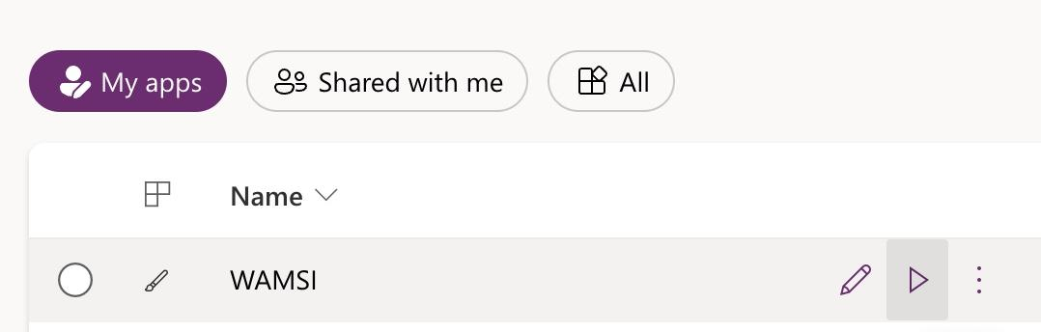

Once you get in, you'll see the main screen of the app. It has two main parts: a 'databases' area and a 'functions' area. The 'databases' area lets you add, change, view, or remove information. The 'functions' area helps you link this information together. You'll also see a back arrow and a home button on the screen (highlighted in a yellow circle). The back arrow takes you to the last page you visited. The home button takes you back to the main starting page.

**A screenshot is shown below:**

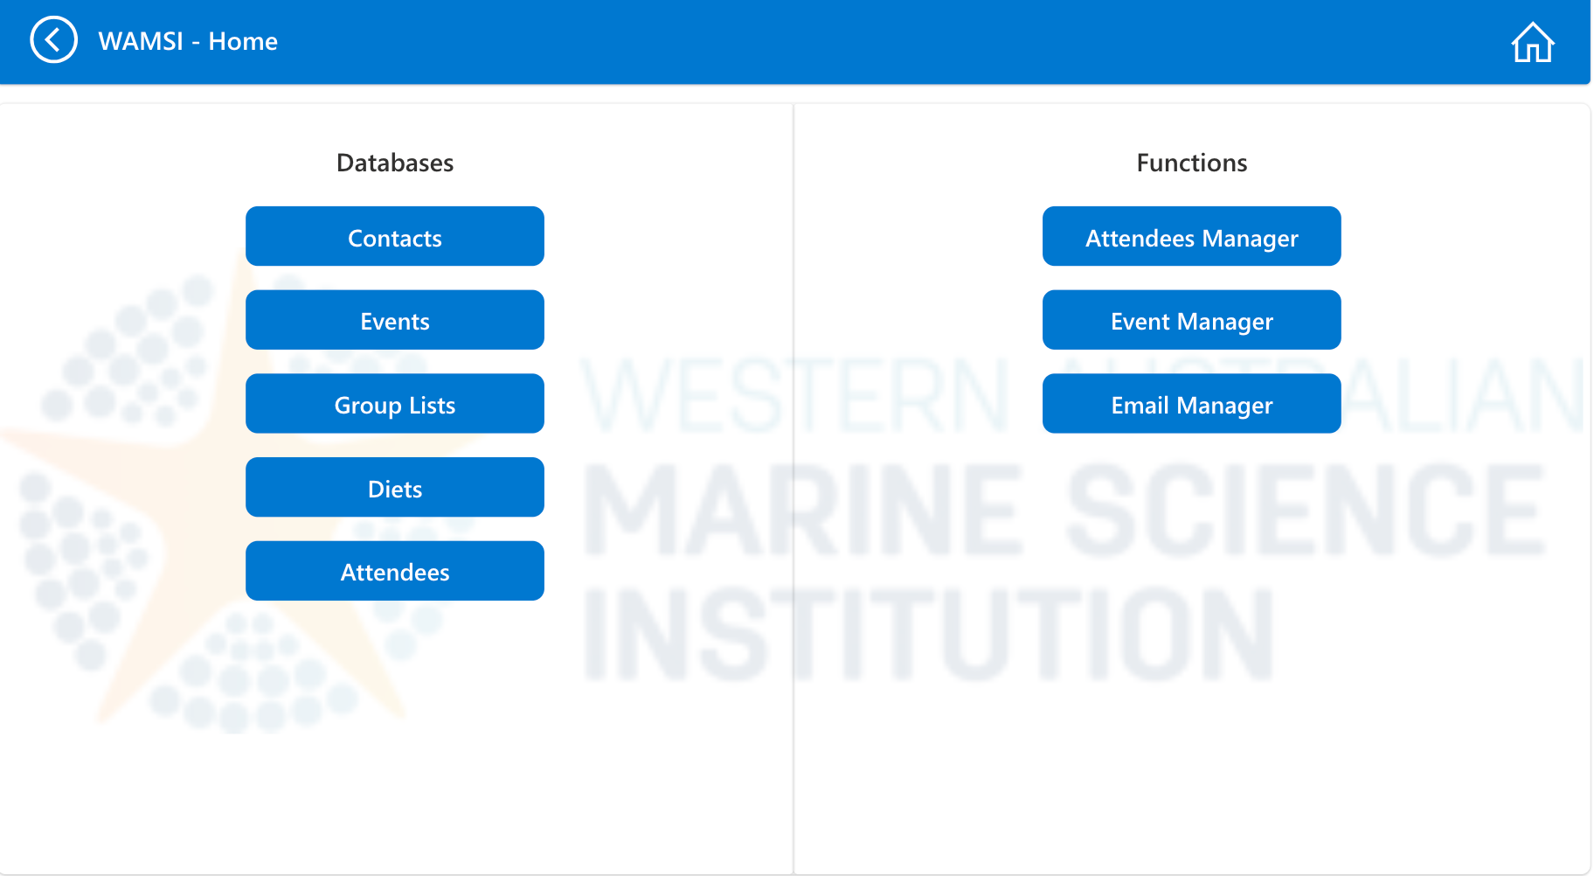

# Features

## Attendees Manager

In the first feature called "**Attendees Manager** " you can search for a specific event. Here, you can add people who will attend and see details about them. This includes whether they said yes or no to coming, if they actually showed up, if they're speaking, and their food preferences. You can also see the contact details of the people attending and information about the event at the bottom of the screen.

**A screenshot is shown below:**

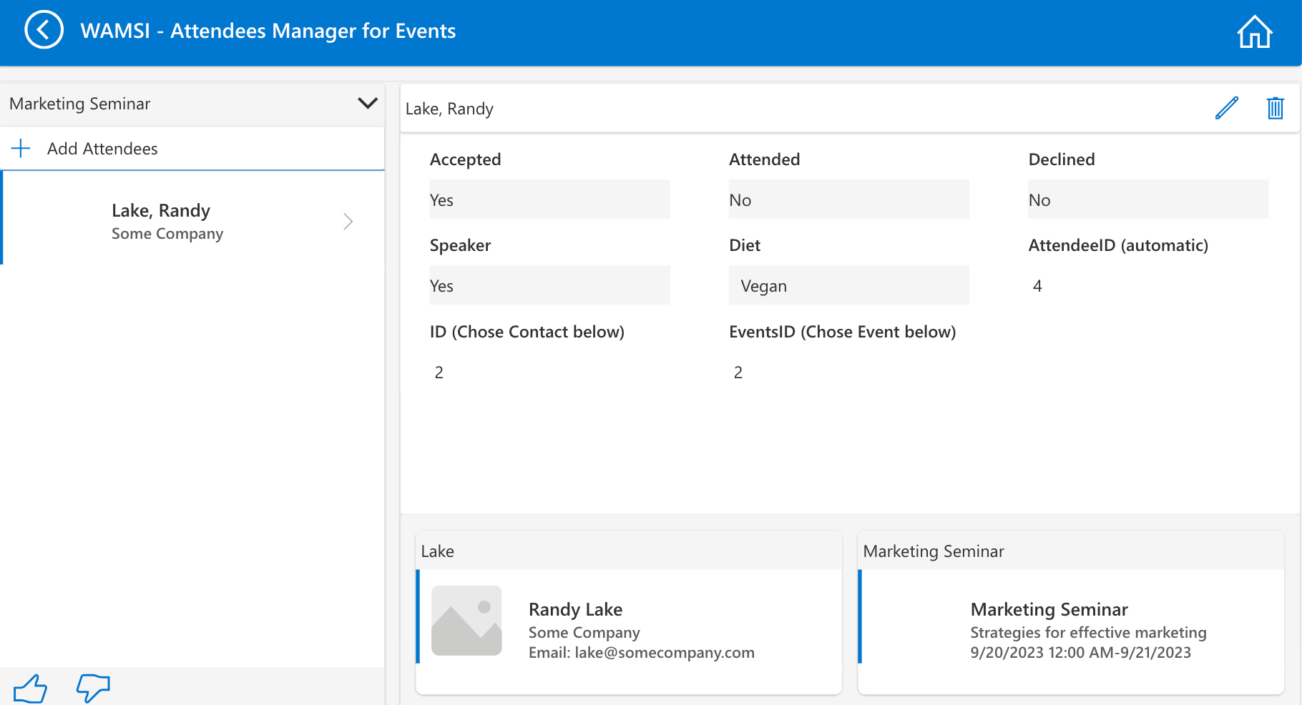

## Event Manager

The second feature is called "**Event Manager**." In this section, you can create or change events, and add attendees to them based on groups. There's also a button to see each attendee's details, which takes you back to the first feature. This way, you can manage everything from one page. Additionally, you can generate reports right from this function.

**A screenshot is shown below:**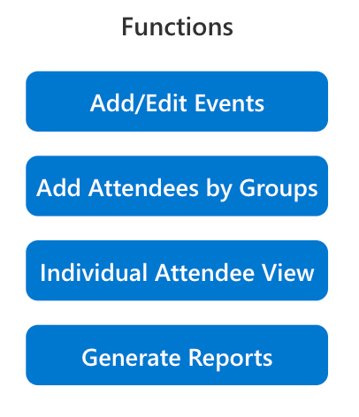

- This is where you can create or change events.

- This is where you can add people to the event based on groups.

- This takes you back to the first feature for managing attendees.

- This is where you can make a report with the information you want to include.

## Email manager

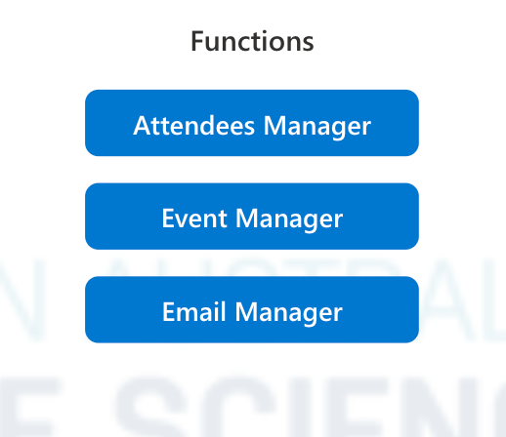

The third feature is "**Email Manager**" You can use it to send event invites to people's email calendars. After they respond, the system updates to show who's coming. The invitation includes all event details. There's also a "**Generate Emails**" button. This lets you easily send a follow-up email to attendees, like a thank-you note or a summary of the event.

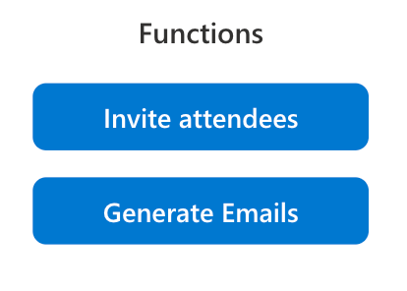

- The first button is shown in the screenshot below.

- The second button helps you find the email details for a specific event.

**A screenshot is shown below:**

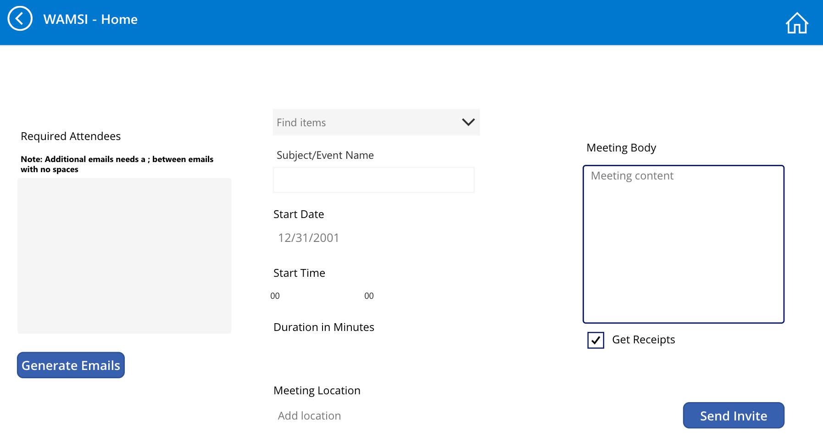

# [Overview of the CRM application](https://github.com/charles-so/Access-to-SharePoint-CRM-Migration/blob/main/Sprint%203/Finn's%20documentation.md#overview-of-the-crm-application)

## [Power Apps](https://github.com/charles-so/Access-to-SharePoint-CRM-Migration/blob/main/Sprint%203/Finn's%20documentation.md#power-apps)

**The group has decided to utilise the Microsoft Power App platform when completing this data migration and CRM implementation. Power Apps are a collection of apps, services, and connectors, as well as a data platform, that provides a rapid development environment to build custom apps for business needs. Using Power Apps, you can quickly build custom business apps that connect to your data. Power Apps is a low code solution to a CRM, which can be continually improved and automated.**

## [Reasons for App Design Choice](https://github.com/charles-so/Access-to-SharePoint-CRM-Migration/blob/main/Sprint%203/Finn's%20documentation.md#reasons-for-app-design-choice)

1. **The group decided to leverage the Microsoft Power Apps platform rather than build the application from scratch. If we were to build the app completely ourselves and something were to happen with the application, it would be difficult for an external party to fix any issues or bugs. However, as Microsoft applications are widely adopted and used in business practice, it would be much easier to fix any issues with a Power Apps application.**
2. **SharePoint and Power Apps are both Microsoft platforms. This means that integration of the Power App designed by the group will be much easier to integrate into SharePoint. The Power App should also run much smoother in SharePoint compared to other applications.**
3. **Power Apps have a range of built-in security functions for data management. Given the time constraints, these security functions will be much more comprehensive than what the group could have designed. This means that WAMSI will have tight control over how different users can access the data and various records.**
4. **Power Apps can run in browsers and on mobile devices, making the database more conveniently accessible for database managers.**

# [Set Up Instructions](https://github.com/charles-so/Access-to-SharePoint-CRM-Migration/blob/main/Sprint%203/Finn's%20documentation.md#set-up-instructions)

**Due to the restrictions the group has regarding administrative privileges and the university IT processes, we will be unable to set up the App for WAMSI ourselves. However, below is a comprehensive set of instructions for the IT to set up the App on the WAMSI server.**

## [Starting Power Apps for the first time](https://github.com/charles-so/Access-to-SharePoint-CRM-Migration/blob/main/Sprint%203/Finn's%20documentation.md#starting-power-apps-for-the-first-time)

1. **Go to the Power Platform admin centre:** [**https://admin.powerplatform.microsoft.com/home**](https://admin.powerplatform.microsoft.com/home)**. This is a page where you can create an "environment" so you can control access to the app and data.**
2. **In the left navigation pane select "Environments". This will show you your current environments which you can use for power apps. Here you can create a new environment and add specific users.**
3. **Next, go to** [**https://powerapps.microsoft.com/en-us/**](https://powerapps.microsoft.com/en-us/) **and select "sign in" in the top right of the page. This is where the actual power app will be.**
4. **The left panel is the navigation panel, and contains elements such as "Apps" and "Tables". In the top bar, the environment you are working in will be displayed. Click on this environment and change to the environment you want to work in.**

## [Downloading the Power App into your environment](https://github.com/charles-so/Access-to-SharePoint-CRM-Migration/blob/main/Sprint%203/Finn's%20documentation.md#downloading-the-power-app-into-your-environment)

1. **The Power App will be sent to you in the form of a zip file. In Power Apps, go to "Apps" in the left navigation pane. Click on "Import canvas app".**
2. **Upload the zip file on the import package page. Once the app is uploaded, you should see the page below. Make sure the import setup option is set to "Create as new".** 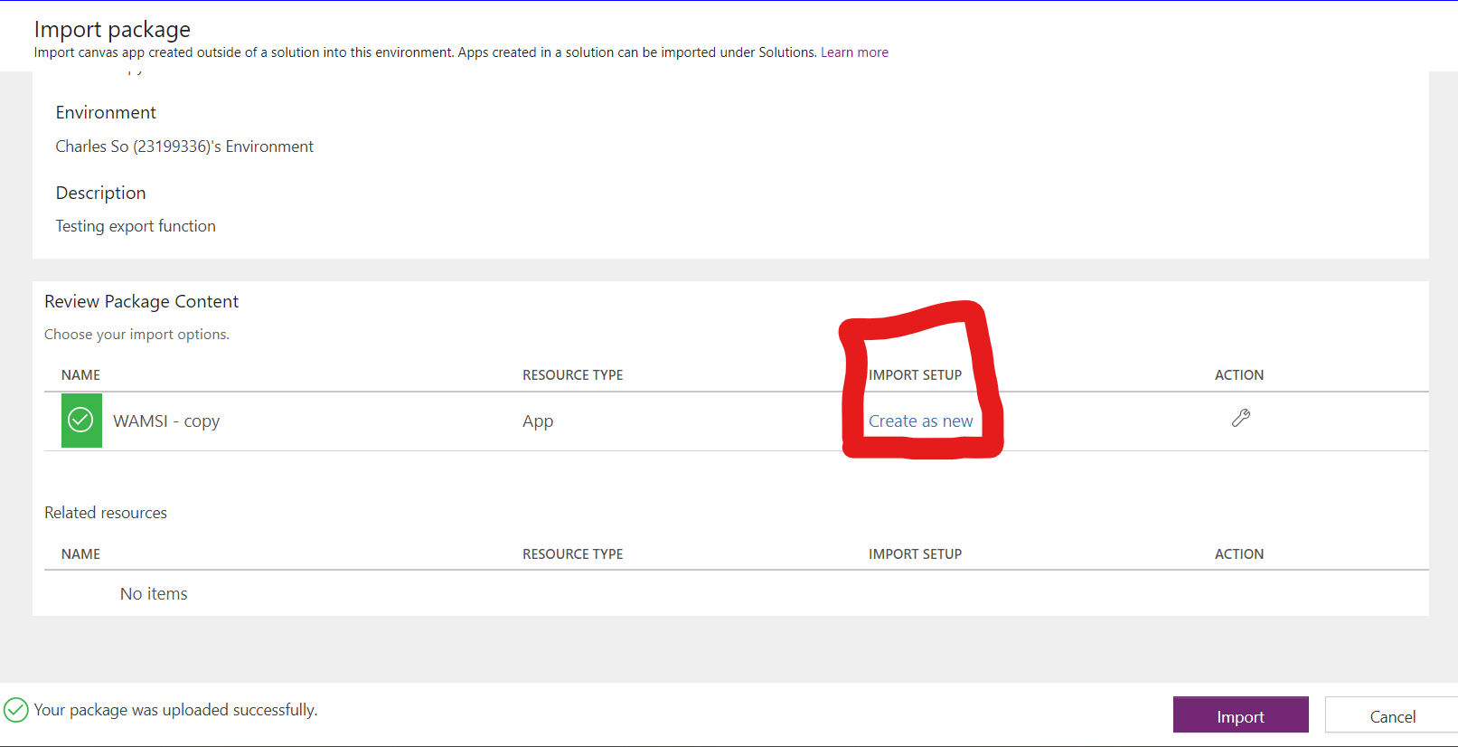
3. **Click import at the bottom of the screen. Once this is complete you will receive a message: "All package resources were successfully imported".**
4. **Press back and click on "Apps" on the navigation pane. Your app should appear under "My apps". Click on your app and press "Allow" for any connection requests.**

## [Downloading Data into the App](https://github.com/charles-so/Access-to-SharePoint-CRM-Migration/blob/main/Sprint%203/Finn's%20documentation.md#downloading-data-into-the-app)

1. **In the App, under the "Data" heading in the navigation pane, you should see the tables used by the app. Currently, the list contains the variables for the tables used by the app, but the actual tables have not been imported yet. You need to import the tables of the database to your environment and then press add data in the app. It is important to call the tables the same names as the tables currently acting as placeholders in the app, as this is the variable name called by the app.** 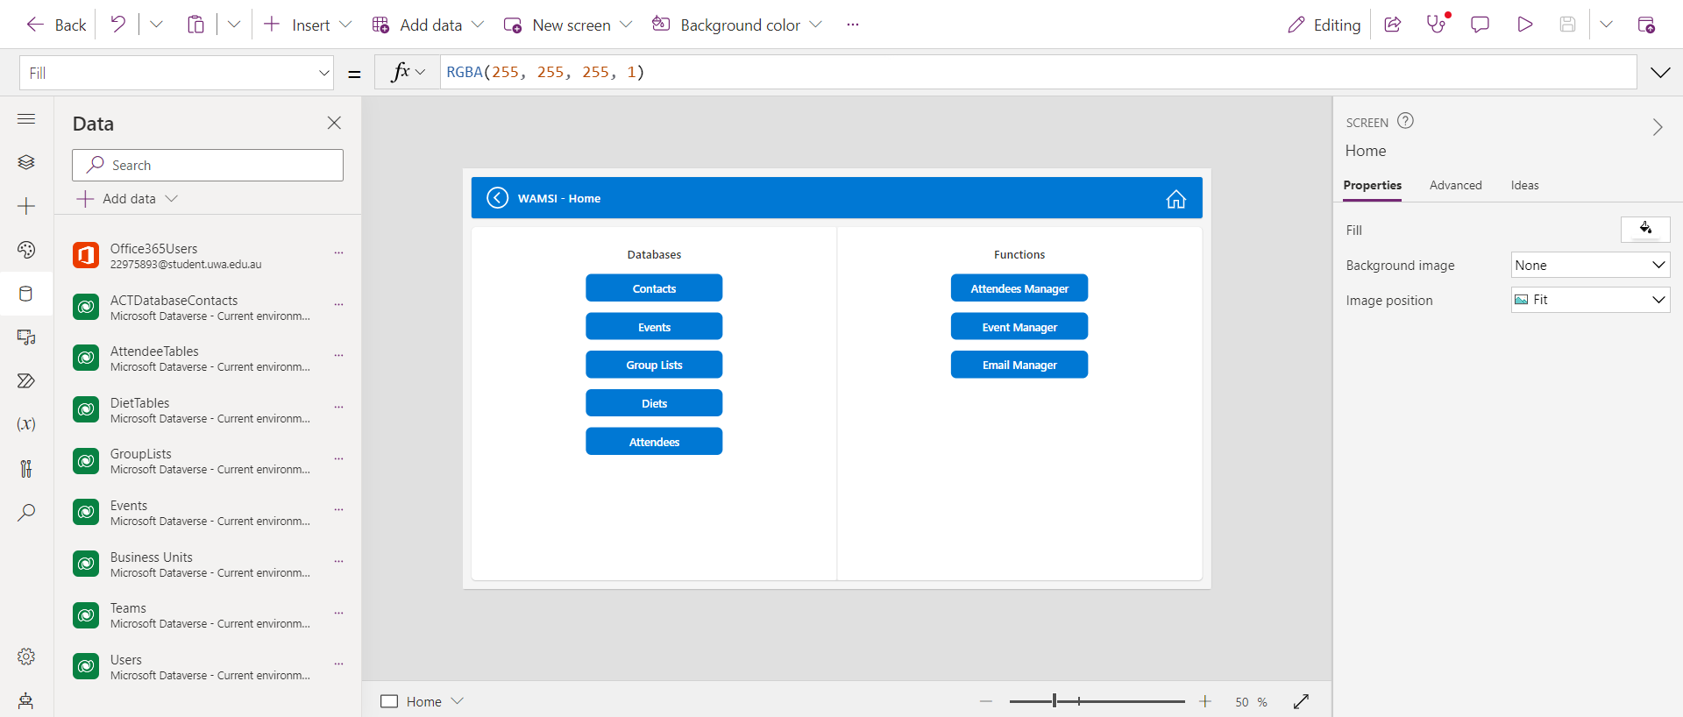
2. **There are 8 tables that need to be imported for the app: "ACTDatabaseContacts", "AttendeeTables", "DietTables", "GroupLists", "Events", "Business Units", "Teams" and "Users". Export these tables from the Microsoft Access database as Excel files.**
3. **On the Power Apps page, go to "Tables" on the left navigation pane. Click "Upload an Excel file".** 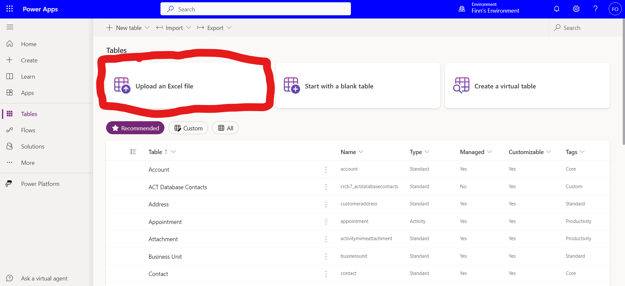
4. **Upload each file, making sure to name the table correctly according to how the table is named in the app.**
5. **Now under "Data" on the Power App, delete all the data listed and select "Add data" to import the actual tables.**

## [Integration with Sharepoint](https://github.com/charles-so/Access-to-SharePoint-CRM-Migration/blob/main/Sprint%203/Finn's%20documentation.md#integration-with-sharepoint)

**The following instructions are summarized in this video:** [**https://www.youtube.com/watch?v=k6LM6IItZYM**](https://www.youtube.com/watch?v=k6LM6IItZYM)

1. **Under the "Apps" page in Power Apps, click on the 3 dots next to your app name and select "Details". On the page copy the App ID.**
2. **Next, navigate to the Sharepoint site where you want to insert the power app.**
3. **Click Edit > Add a new web part > Microsoft Power Apps. Paste the App ID when prompted.**
4. **Click republish in SharePoint and then sign in to the app on SharePoint in order to use the app.**